Pets: Dogs are permitted at the sole discretion of Owner pursuant to a separate Pet Addendum signed by Guest and Owner and an additional $195 Pet Fee.

POINT LOBOS RENTALS / WHISLER RILEY PROPERTIES
LODGING LICENSE AGREEMENT

This Lodging License Agreement (“License”) is entered into on Current Date by and between Whisler Riley Properties “Owner” and Guest, Guest”.

- Property. Owners possess certain real property (“the Property”) situated at 47 Highway 1, and 55 Riley Ranch Carmel, California and commonly known as “The Walers Cottage, The Sea Otter Cottage, The Abalone Cottage and The Acorn Ranch Home”. Guest is granted this license as to only a portion of the Property, which portion is hereinafter defined as the “Premises”. The Premises consists of the following areas identified on the site plan attached hereto as Exhibit “A” and incorporated herein. No permission is given for Guest to use any other portion of the Property, without prior written approval from Owner.

- Grant. In consideration of the sum of Lodging Fees and 10.5% Transient Occupancy Tax included, (“License Consideration”), Owner grants to Guest a license to use the Premises as follows:
  - Check-In & Check Out: To occupy the Premises for lodging purposes on the date(s) booked on www.PointLobosRentals.com (the website) (the “Occupancy Term”). This License begins at 3pm on the first date described above (“Check-in Date”) and ends at 11am on the last date described above (“Check-out Date”).
  - Maximum Guests: The maximum number of overnight guests is limited to as listed on the website (no exceptions this includes small children and infants). A maximum of day guests as listed on the property description on the website may be present on the premises in addition to overnights. Any violation of this maximum occupancy will be considered a breach in the agreement and the Guest will be asked to depart the property.
  - Use of Premises: Guest may not use the Premises in any manner or for any other purpose other than that described in this License without obtaining Owner’s prior written consent.

- Security Deposit. In addition to all other consideration and service fees provided herein, Guest shall acquire a damage insurance policy or provide Owner with a security deposit which may be applied by Owner against any excessive clean up, damage, penalties for non-adherence to this License, or other liabilities incurred as a result of the Guest’s use of the Premises. Owner agrees to return or release funds (minus damage, costs, or penalty fees) no later than 15 days after both: (1) Guest’s departure and (2) after all of Guest’s consideration required under this License has successfully cleared and been transferred to Owner.

- Licensee Nonassignable. This License is personal to Guest and shall not be assigned. Any attempt to assign the License shall automatically terminate it. No legal title or leasehold interest in the Property is created or vested in Guest by the grant of this License.

- Travel Insurance. Owner encourages Guest to secure traveler insurance.

6. Indemnity. Guest agrees to hold Owner exempt and harmless from and to defend Owner against any and all claims for personal injury on the Property, damage related to or caused by or arising out of Guest’s use of the Property or which occur to Guest or to any persons who come onto the Property as a result of this License. Guest shall sign the Release and Waiver Agreement attached hereto and incorporated herein as Exhibit “C”.

7. uNFORESEEABLE ACTS OF GOD, natural disaster or GOVERNMENTAL action. If Owner must revoke this license due to fire, electrical failure, earthquake, war, or other act of God or natural disaster, or if governmental agencies seek to enjoin use of the Property by Guest, oWNER SHALL reimburse gUEST the amount of the License Consideration as liquidated damages. The parties agree that this amount is a reasonable sum given that it is impractical or extremely difficult to establish the amount of damages that would actually be suffered by Guest if the guest use LICENSE must be canceled due to FIRE, ELECTRICAL FAILURE, EARTHQUAKE, WAR, OR OTHER ACT OF GOD or GOVERNMENTAL action.
Owner’s Initials:__pw___

9. Agreement Effective Date : Guest may consider this agreement to be in effect once Guest has booked the property and paid a deposit

10. Fee Schedule:
As listed on the property website www.pointlobosrental.com

11. Cancellations: If Guest wishes to cancel their reservation, the policy is the following:
A) 60 days or more- 100% refund
B) 31 to 59 days- 50% refund
C) 30 days or less- no refunds

12. Entire Agreement: This Agreement constitutes the entire agreement between Owner and Guest relating to the License. Any prior agreements, promises, negotiations, or representations not expressly set forth in the Agreement are of no force and effect. Any amendment to this Agreement shall be of no force and effect unless it is in writing and signed by Owner and Guest.

OWNER:

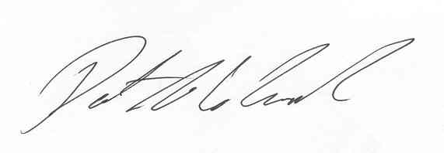
Whisler Riley Properties

By: Patrick Whisler

Exhibit “A ”
PREMISES / USE AREA THE WHALERS COTTAGE

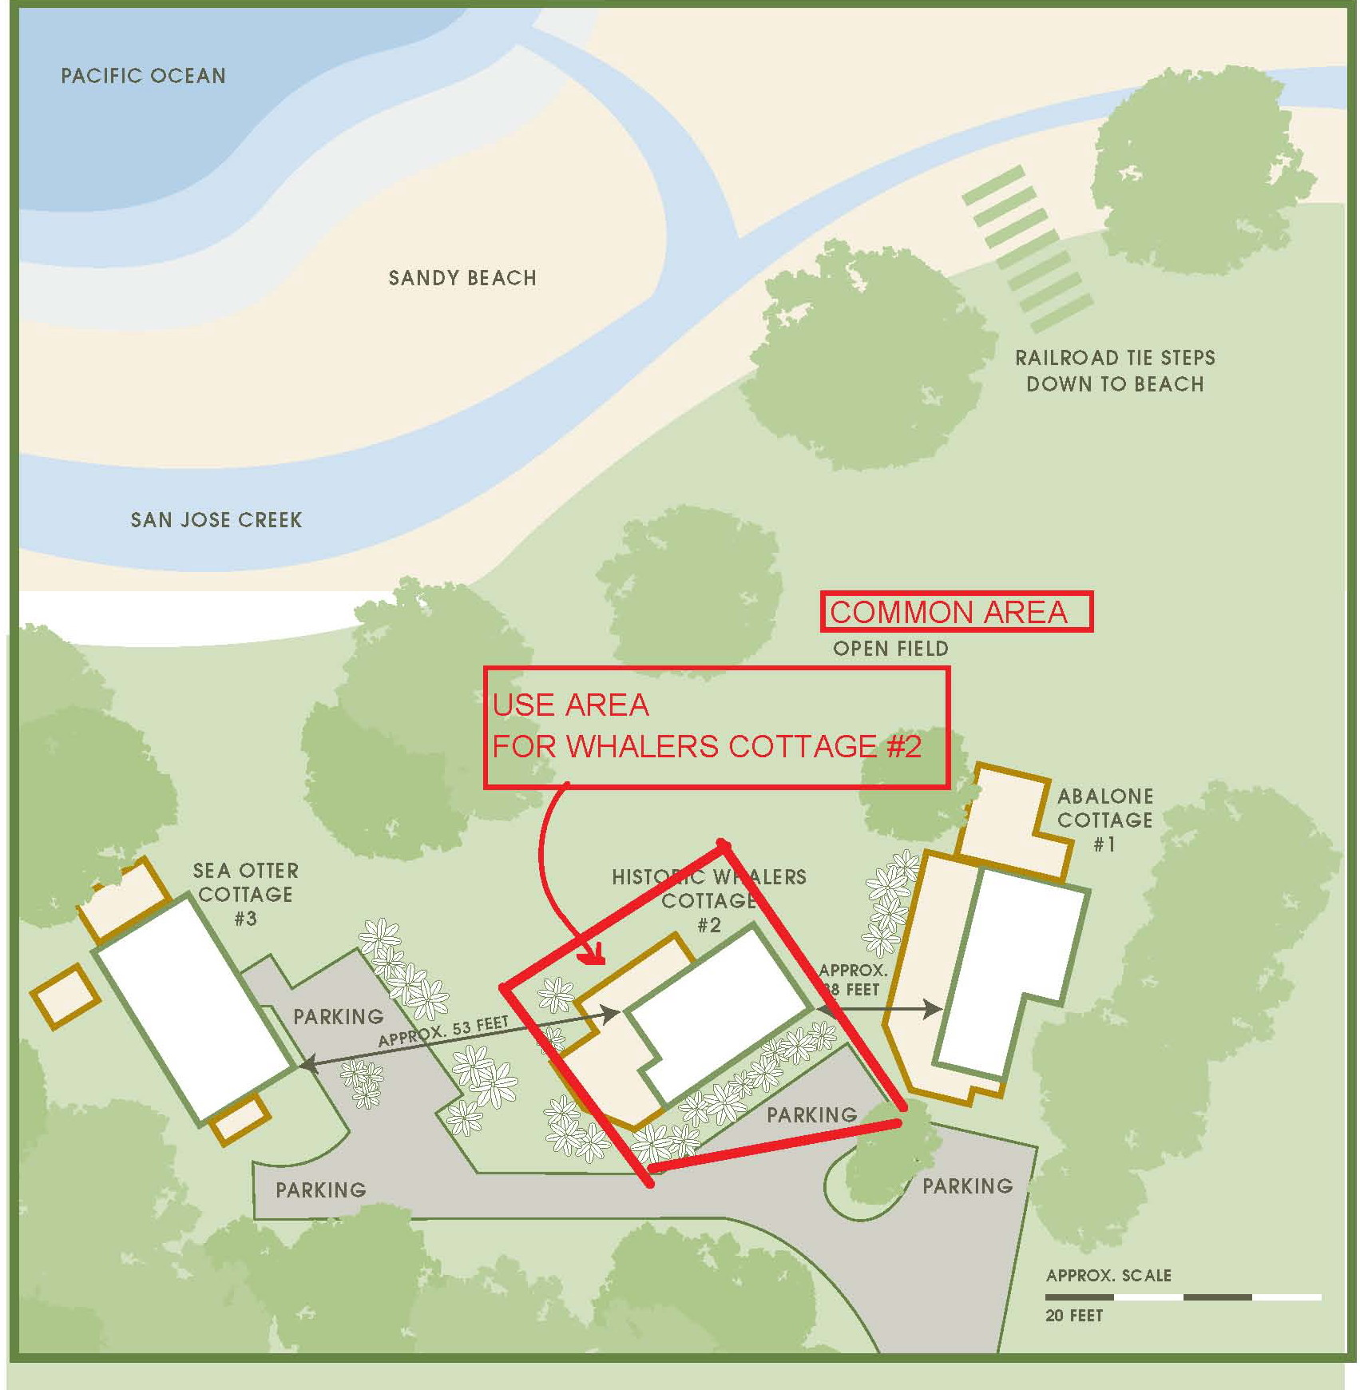

Exhibit “A ”
PREMISES / USE AREA THE SEA OTTER COTTAGE
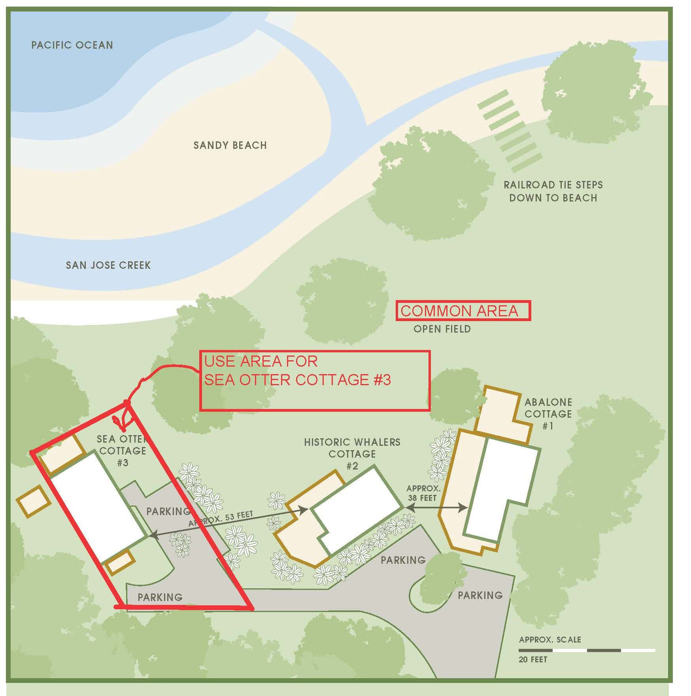
Exhibit “A ”
PREMISES / USE AREA THE ABALONE COTTAGE

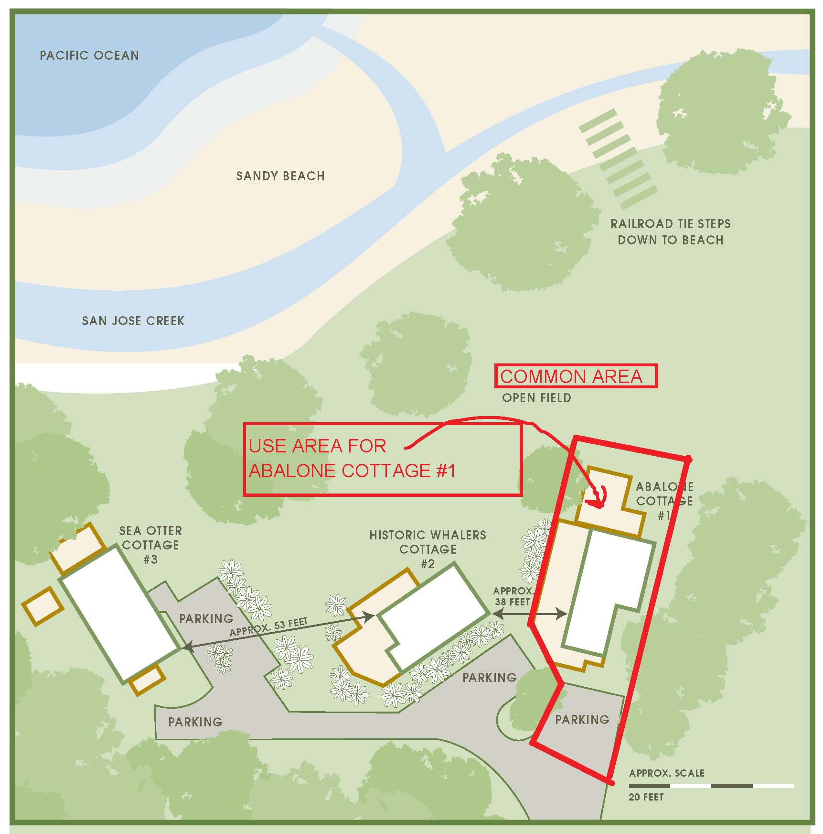
Exhibit “A”
Premises Use Area The Acorn Ranch Home
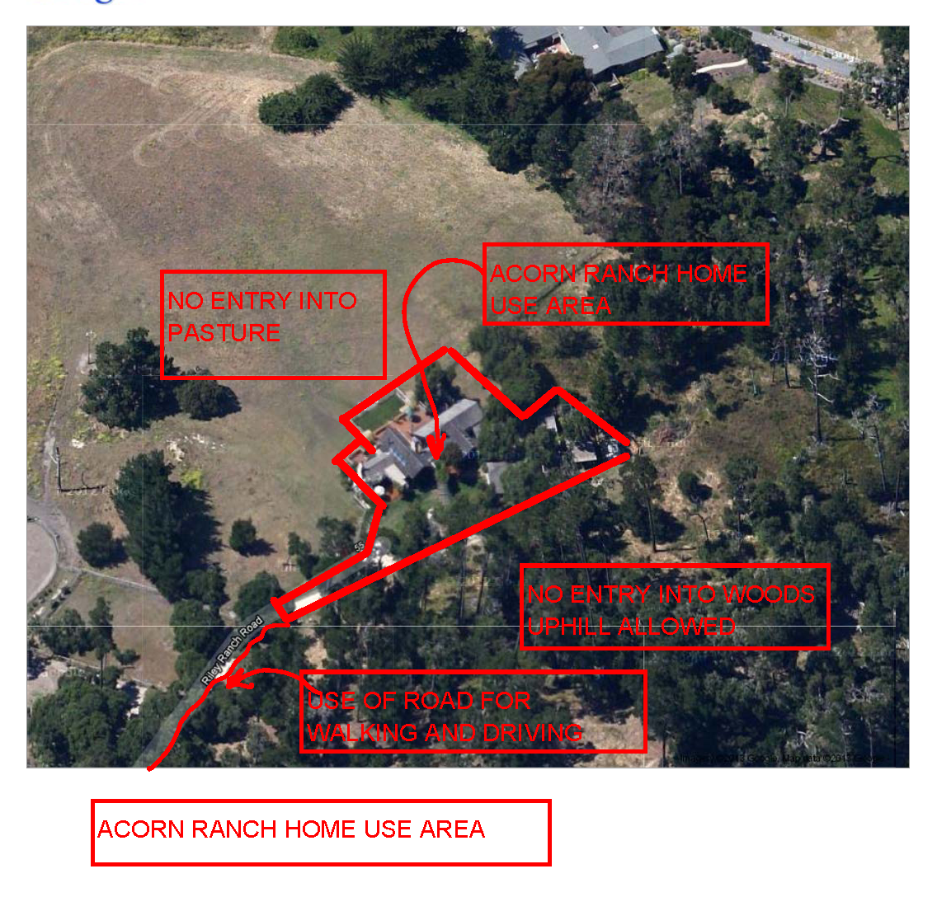

Exhibit “A”
Premises Use Area The Acorn Ranch Home

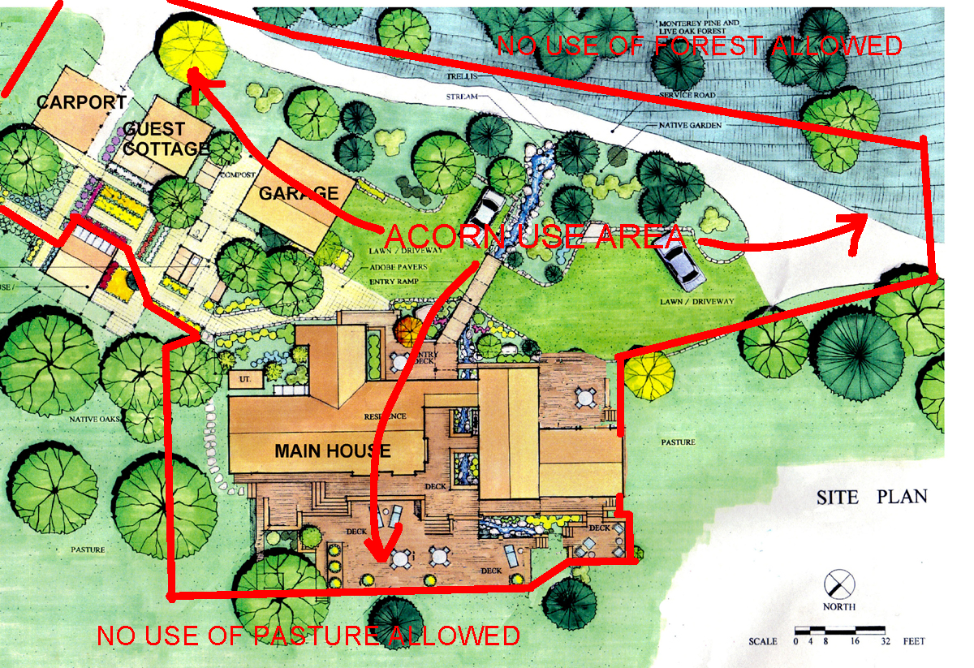

Exhibit “B ”
Rental Rules

The following restrictions shall apply to Guest’s use of the Premises (including use of the Premises by any overnight lodging guests or day visitors) pursuant to this License:
- No Smoking: Smoking is prohibited within any structure. Smoking outside is acceptable provided it is done in a fire safe area and all smoking related trash is placed in a fire safe receptacle.
- Pets: Pets are permitted at the sole discretion of Owner pursuant to a Pet Addendum signed by Guest and Owner.
- Named Guests: Guest shall in writing provide Owner with names of all overnight lodging guests 3 days prior to the Check-in Date. Visitors other than those overnight lodging guests declared by Guest may not stay on the Premises overnight.
- No Events or Parties: Guests acknowledges that large parties or events (weddings, receptions, large dinner parties, etc.) involving more than 2 day guest visitors to the Premises in any 24 hour period are not permitted.
- Quiet & Courteous Conduct: Guest understands that they are lodging in a residential neighborhood and agrees to conduct themselves in such a way as to maintain the peace and tranquility of the neighborhood. Guest shall not disturb, annoy, endanger, or interfere with any neighbors.
- Loud Music: All music or noise (amplified or otherwise), loud enough to be heard within 50 feet of structures shall cease by 10pm.
- Parking: Parking of no more than 2 vehicles at the Cottages and 3 vehicles at the Acorn Ranch Home is restricted to the established parking areas. The driveway it to be kept free and clear at all times for emergency vehicle access. Any cars blocking access along the driveway will be subject to towing and all towing fees will be the responsibility of Guest and the vehicle owner.
- Housekeeping: There is no daily housekeeping service. Linens and bath towels are provided in the residential unit but daily maid service is not included in the License Consideration. Only striped beach towels can be taken from the residential unit for outside use.
- Fireplaces: The Property is located within a High Fire Hazard Area. All fires are restricted to the indoor fireplaces. Fireplaces are wood burning. Screens must be kept in place during use and fires must be supervised at all times.
- Water and Septic Utilities: The Premises are served by municipal water and a septic system for sewage disposal. Please help use conserve water. Guest may be charged for water use in excess of 1,000 gallons per day (average water use is less than 100 gallons per day per person). The septic system is fully operational but will clog if improper material is flushed. DO NOT FLUSH anything other than toilet paper. No feminine products should be flushed at any time. If it is found that feminine products or other materials have been flushed you may be charged the full cost to remedy any septic system clog.
- Cleaning: Guest shall leave the Property in as neat and clean condition as Licensee finds the Property. If the Premises appear dirty of damages upon Check-In, Guest shall inform Owner immediately. Owner will charge an additional $275 cleaning fee for any extensive cleaning required after guest checks out.
- Safe Conduct: Guest assumes full and complete responsibility for the safety and conduct of all persons utilizing the Premises. Guest shall ensure that no person drives a motor vehicle to, on, or from the Premises while under the influence of alcohol or drugs.

Exhibit “C”
RELEASE FROM LIABILITY

- Voluntary Participation. I, the undersigned, acknowledge that I intend to voluntarily make the Premises available for use by overnight lodging guests and day visitors and collectively with my guests utilize the Premises for recreational and lodging purposes consistent with this License.

- Assumption of Risk. I am aware and acknowledge that this activity is being held on the Premises, which is rural residential property. I am voluntarily utilizing the Property with knowledge of any dangers involved, and hereby agree to accept and assume any and all risks of injury or death to myself and any guests, including minors, as a result of entering and utilizing the Premises, whether such risks are patent or latent, and verify this statement by signing this document. I understand that these risks include but are not limited to the following:

    - Adjacent to the Premises are many unfenced steep cliffs and bluffs.
    - Carmel River State Beach (aka Monastery Beach) may be accessed from the Premises but is subject to dangerous surf, including rogue waves and undertow. No lifeguards are on duty and children should never be left unattended at this beach. Because of the dangerous surf, swimming is not permitted. Dogs are required by State Parks to be on a leash at all times.
    - The Premises and its adjacent surroundings are home to many types of potentially hazardous plants and animals, including but not limited to: Mountain Lions, Coyotes, Bobcats, and Poison oak.

- Release. The following are the released parties: Owner, including any person or entity with a beneficial interest in Owner or title to the Property (collectively referred to herein as “RELEASED PARTIES”). In consideration for being permitted to use the Premises and any facilities and personal property located thereon, I hereby agree that I, my assignees, heirs, distributees, guardians, and legal representatives will not make a claim against, sue or attach the property of the RELEASED PARTIES for injury or damage as a result of my use of the Property, resulting from the negligence or other acts, howsoever caused, by the RELEASED PARTIES or any employee, agent, or contractor of them. I hereby release all RELEASED PARTIES from all actions, claims, or demands that I, my assignees, heirs, distributes, guardians, and legal representatives now have or may hereafter have against RELEASER PARTIES for injury or damage resulting from my participation in the ACTIVITES. This release is irrevocable. Please note we are not responsible for any chemical sensitivity reaction to our cleaning products, we do encourage trip insurance.

- Knowing and Voluntary Execution. I have carefully read this agreement and fully understand its contents and sign it of my own free will.

